Factors Impacting the Use of Telehealth for Medicare and Medicaid Members

**Jessica Coomber**

Data Analytics 401 - Senior Seminar

Dr. Alexandre Scarcioffolo

Denison University

2025

**To do:**

* **Abstract**
* **Literature review**
* **Add notes to visuals if needed**
* **Discussion**

**Abstract**

INSERT

**Introduction**

The use of telehealth has increased since 2020, but it could be falling short of its potential to improve access to care for everyone in the population. This research aims to determine factors that are impacting the use of telehealth for Medicare and Medicaid members. I focus on factors that suggest economic status of individuals, such as number of vehicles owned and types of internet access, to see how they are impacting the utilization of telehealth visits. I expect that disadvantaged populations with a perceived lower economic status will also show a lower utilization of telehealth services because of the financial barriers to its access. A potential limitation of the results is that there is not one variable to represent the financial status of the individuals so inferences will have to be made based on other variables.

**Literature Review**

Existing research on the use of telehealth highlights its potential to expand access to medical care while also raising questions about whether it is truly bridging gaps in healthcare access or if it is increasing existing disparities. In order to understand its impact, it is important to clarify what types of services telehealth refers to. The term telehealth is mistakenly thought of as only including video calls, but it also includes phone consultations, secure messaging, remote monitoring of health through wearable devices (Wosik, 2020). The adoption of telehealth increased during the COVID-19 pandemic and it has become more mainstream in recent years (Wosik, 2020 ; Gajarawala and Pelkowski, 2021). Even with the increased adoption of telehealth in the US, concerns remain around whether there is actually an improvement for lower income populations who might not have access to the internet or technology and they might not have the same comfort using technology (Douthit, 2015). This literature review will be organized thematically, exploring themes such as barriers of access to healthcare, barriers of access to telehealth and its utilization trends, and healthcare costs. Understanding these factors is important in understanding how to reach telehealth's potential to improve the equality of healthcare access and overall population health.

Singh et al., (2018) identifies that some of the ongoing barriers of healthcare access come from social determinants of health, which include community factors such as socioeconomic status and geographic location. Several studies explore the ways in which the implementation of telehealth has increased in recent years, but is still not reaching its potential because of a lack of access to the needed technology for rural or low income populations.

The use of telehealth services has evolved significantly in recent years, particularly during the COVID-19 pandemic when there was a need for a fast adoption and integration of telehealth into healthcare systems (Wosik, 2020 ; Gajarawala and Pelkowski, 2021). This increase is seen in an analysis of private insurance data, which shows that telehealth visits increased from 0.3% of total healthcare contacts in 2019 to 23.6% in 2020 (Weiner, 2021).

These privately insured individuals may be more wealthy and represent a more privileged portion of the US population who was more easily adaptive to new technologies. This increased convenience for a portion of the US population may also be able to reach a previously unmet demand by individuals who would not have seeked any care if it were only offered in person. It is possible that this new utilization may increase overall health care spending even though there are lower costs per telehealth visit for patients (Ashwood et al., 2017).

While Tuckson (2017) highlights telehealth's progress in expanding care access, addressing provider shortages, and increasing convenience, Douthit et al. (2015) suggests that rural populations, low-income communities, and elderly individuals often face difficulties in utilizing telehealth services because of low technological comfort and unreliable internet access. A key factor contributing to these barriers in access to telehealth is that about 1/4 of American households in rural areas are lacking internet access, making virtual healthcare inaccessible to many who need it the most (Lythreatis et al., 2022 ; Douthit et al., 2015). Although it may seem like telehealth can be used to connect rural hospitals with specialists, increase access care for underserved communities, and make the healthcare system more efficient, it is important to assess whether this is actually the case given the barriers socioeconomically disadvantaged populations may still face to access telehealth (Wosik, 2020).

Lastly, another area of research explores the financial implications of telehealth, particularly its impact on healthcare spending and the diverse approaches to insurance reimbursement. The increased utilization of telehealth does not necessarily correlate with reduced healthcare spending (Ashwood et al., 2017).

Telehealth visits often serve as an additional point of care rather than a direct replacement for in-person visits, potentially leading to higher cumulative healthcare costs. For example, a study by Weiner (2021) found that people who used telehealth had higher overall medical costs. However this correlation does not necessarily mean that telehealth is more expensive but could mean that those people could have already been dealing with more health problems and are therefore using telehealth more frequently.

**Data**

The *Medicare Telehealth Trends* dataset used in this research is publicly available through Data.gov, a platform that provides open government data permitting use for research. The variable names were renamed from the names in the original dataset for easier interpretation. Variable definitions were found in the *Medicare Telehealth Trends Data Dictionary.* This dataset includes the demographic information about Medicare and/or Medicaid members and whether they reported using telehealth services during and after the pandemic. The observations in this dataset are anonymous and I will not be handling specific personal health information.

The *Medicare Telehealth Trends* dataset includes their demographic variables (i.e. race, sex, state), the number of telehealth visits and the number of visits that were eligible to have been telehealth. The number of telehealth visits will be used as the dependent variable of interest as I am trying to understand telehealth utilization. A potential limitation of this study that could affect the interpretation of the results is that the data includes years 2020-2024 and does not include information about telehealth usage before 2020. Without the inclusion of data from a larger time period, analysis was not done based on year.

The *Medicare Telehealth Trends* data is merged with publicly available annual data from the US Census Bureau on state specific factors that could be impacting access to telehealth. These factors are by state and include vehicle access, internet access, and population sizes. These variables are chosen because I hypothesize that the owning vehicles and having internet access vary based on the individual's economic level and impact the ability to access medical care and telehealth services. The vehicle and internet variables are converted to be representing per capita for easier interpretability. To capture individuals who depend on public transportation, likely urban areas, the Transit Spending Per Capita variable was chosen from the *Transit Report Card* from Transportation for America. Transit Spending for each state is adjusted to per person rates to fairly compare states of varying sizes and categorized into 6 categories from low to high. The *Transit Report Card* is merged to the *Medicare Telehealth Trends dataset based on state.*

Additional variables are chosen from Federal Reserve Economic Data (FRED) including annual GDP in billions and unemployment rate as a percentage and are merged to the *Medicare Telehealth Trends* dataset based on year. GDP is converted into a new variable GDP in trillions for easier interpretability in the models. Unemployment Rate has been converted from a percentage to a proportion for easier interpretability. GDP and Unemployment are used to represent the economic status of the US in order to see whether there is a relationship in the economy to telehealth usage.

**Methods**

For initial exploration, I used bar plots to visualize TelehealthVisits (number of unique telehealth visits) across demographics categories (rural/urban, year, and race). These variables are important in understanding the dataset because demographics of individuals influence their ability to access telehealth services (Ching-Ching, 2018). Then, I will use a fixed effect analysis to assess the strength of the impact that the variables have on the number of telehealth visits and how that relationship changes once controlling for state and year. The fixed effect controls for time invariant variables and in this case will control for differences between states and years. Fixed effect will be a beneficial method because it will help isolate variables of influence to see how they are impacting the utilization of telehealth services. 7 variables have been used in a multivariable fixed effect model in relation to telehealth visits. The variables chosen include number of vehicles owned, transit spending per capita, having internet access, number of hospitals, number of physicians, GDP, and unemployment rate. To evaluate the fit of the model from the output, the R^2 will represent how well the model explains variation within each fixed-effect group (state, year, and both). A higher R^2 will suggest that the independent variables are good predictors of TelehealthVisits.

#### **Model Validation**

Standard Errors will be used to assess the validity of the model because they represent the uncertainty and precision (Altman, 2005). Ordinary standard errors are often unrealistic when working with real data because they assume that the errors are homoscedastic (constant variance) and are uncorrelated across observations. For this reason, I will be using the function feols (fixed effects ordinary least squares) in R which defaults to “cluster” when using fixed effects. Cluster assumes that the error terms within the same cluster are correlated. This is needed for the fixed effect model because the data within the same cluster is autocorrelated (correlated with each other). Feols drops variables that are perfectly collinear but if a variable has very high VIF, it might still be problematic and could lead to unstable estimates.

Variance Inflation Factor (VIF) analysis is used to test for multicollinearity, which is when independent variables are highly correlated with each other. When independent variables are highly correlated, the fixed effect model will not be able to determine which variable is leading to the effect and in this case it will capture overlapping aspects of economic status. Correlated variables in a fixed effect model could lead to unreliable coefficient estimates and the interpretation of the impact of each variable could be incorrect.

**Results**

**Figure 1: Telehealth Visits by Rural vs. Urban**

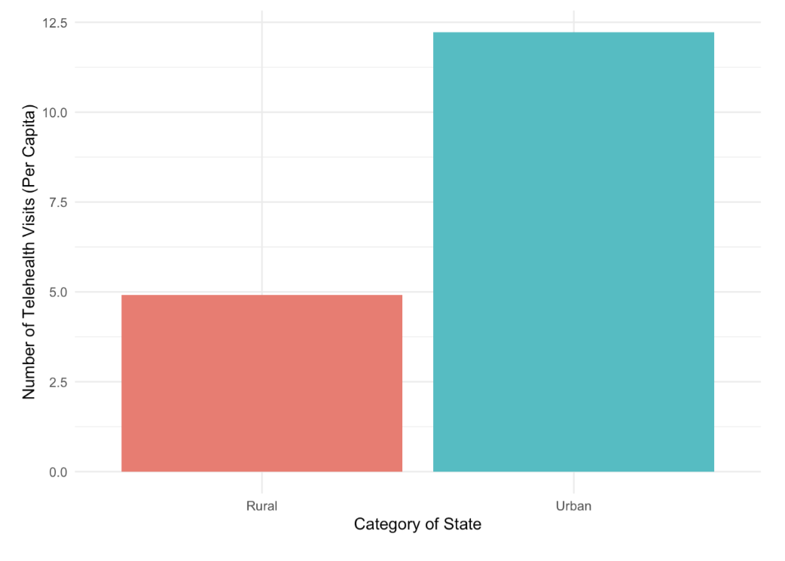

***Figure 1*** shows almost 12.5 telehealth visits (per capita) for urban individuals and only about 5 telehealth visits for those who are rural, which could be because of differing socioeconomic status and access to the internet. Singh et al., (2018) identified that some of the ongoing barriers of healthcare access come from social determinants of health, which include community factors such as socioeconomic status and geographic location. For example, rural populations have a higher lack of access and Douthit (2015) reported that there are over 51 million Americans who live in rural USA.

Another key factor contributing to these barriers in access to telehealth is the digital divide, with about 1/4 of American households in rural areas lacking internet access, making virtual healthcare inaccessible to many who need it the most (Lythreatis et al., 2022 ; Douthit et al., 2015). Even though telehealth is thought to be expanding care access, Douthit et al. (2015) suggests that rural populations, low-income communities, and elderly individuals often face difficulties in utilizing telehealth services because of low technological comfort and unreliable internet access. ***Figure 1*** reinforces Douthit’s concern that telehealth is not reaching its potential and rural populations are lacking.

**Figure 2: Telehealth Visits by Race**

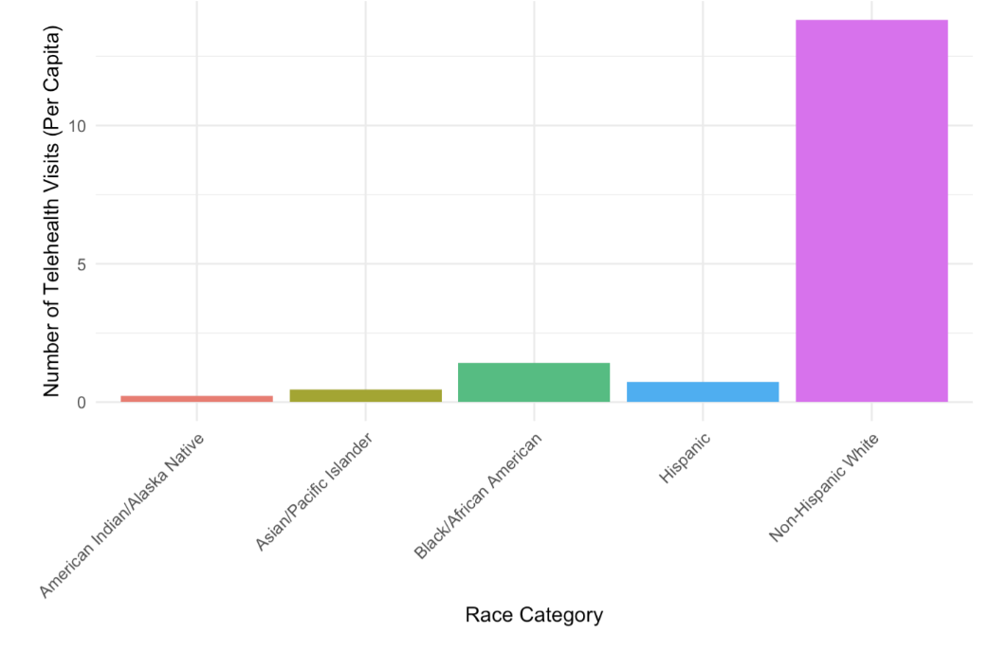

In ***Figure 2*** we can see that telehealth visits are much more common among non-Hispanic white population. This could be because of the advantages and resources available to this demographic. Recognizing that non-white populations have much lower utilization can help target the allocation of resources relating to the implementation of telehealth to improve its access.

**Figure 3: Telehealth Visits by Year**

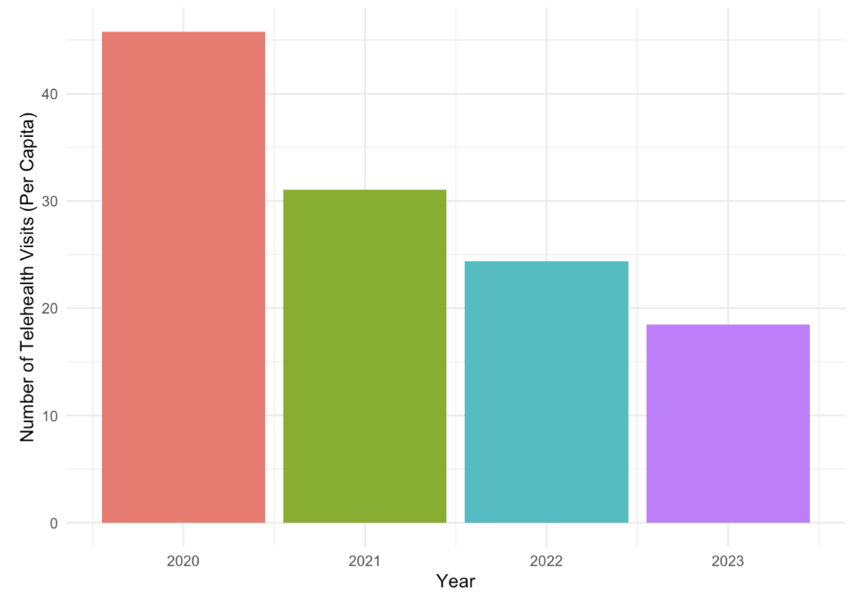

**Figure 4: Eligible Services by Year**

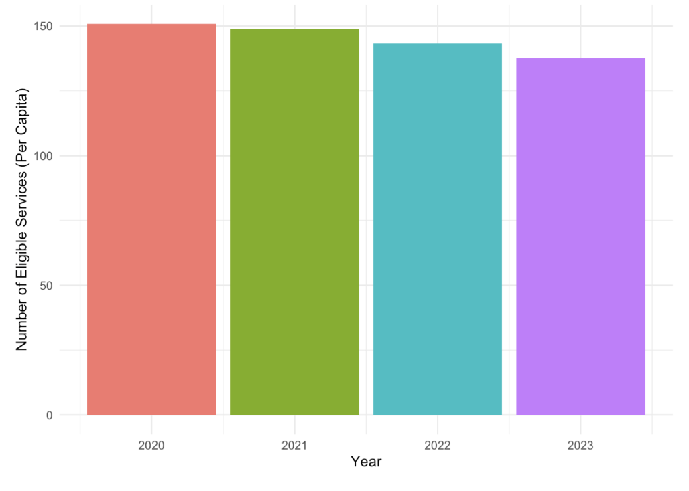

***Figure 3*** shows the number of telehealth visits by year while ***Figure 4*** shows the number of eligible services that could have been used by telehealth. The number of telehealth services was the highest in 2020, likely because the pandemic forced almost all in person visits to become virtual. However, ***Figure 4*** suggests that since 2020 there has only been a small decline in the number of services that are eligible for telehealth use. There are about 150 eligible services for each year and only 50 or fewer telehealth visits. Therefore, this research will provide insight into ways that the use of telehealth services can increase and which populations are currently lacking versus accessing those eligible services.

**Table 1: State and Year Fixed Effects on Various Factors impacting the Number of Telehealth Visits (Per Capita)**

|  |  |  |  |
| --- | --- | --- | --- |
| **Variable** | **No Fixed Effect** | **State Fixed Effect** | **State and Year Fixed Effect** |
| **Vehicles Owned** | **0.010+** | **0.116\*\*\*** | **0.100\*\*\*** |
|  | (0.006) | (0.021) | (0.022) |
| **Transit Spending Per Capita** | **0.000\*\*\*** | **0.006\*\*\*** | **0.005\*\*\*** |
|  | (0.000) | (0.001) | (0.001) |
| **With Internet** | **-0.013+** | **-0.091\*\*\*** | **-0.064\*\*** |
|  | (0.007) | (0.015) | (0.020) |
| **Hospitals Count** | **-35.235\*\*\*** | **-1655.187\*\*\*** | **-1667.191\*\*\*** |
|  | (5.027) | (323.603) | (323.618) |
| **Number of Physicians** | **2.114\*\*\*** | **88.606\*\*\*** | **90.386\*\*\*** |
|  | (0.215) | (14.347) | (14.368) |
| **GDP** | **0.000\*\*\*** | **0.000\*\*\*** | **0.003+** |
|  | (0.000) | (0.000) | (0.002) |
| **Unemployment Rate** | **0.048\*\*\*** | **0.025+** | **0.125\*\*** |
|  | (0.011) | (0.013) | (0.048) |
| **Num.Obs.** | **19330** | **19330** | **19330** |
| **State Fixed Effects** | **No** | **Yes** | **Yes** |
| **Year Fixed Effects** | **No** | **No** | **Yes** |
| **R2** | **0.090** | **0.139** | **0.139** |

Note: Statistical significance of coefficients is shown by *p < 0:10 **p < 0:05 ***p < 0:01 ****p < 0:001. Standard Errors are included in parenthesis.

The coefficients for ***Table 1*** represent the estimated change in the number of telehealth visits associated with a one unit increase in each independent variable, if all other variables stayed constant. When there is no fixed effect, the R^2 is 0.090 which suggests that the number of telehealth visits is explained little by the variables in this model. Adding state fixed effect or state and year fixed effect, the R^2 is 0.139 meaning the fixed effect improves the model and explains more of the variation in the number of telehealth visits due to the independent variables.

The **“Vehicles Owned”** variable’s relationship to the number of telehealth visits changes from 0.010+ to 0.100*** after controlling for the fixed effects. Therefore, more cars owned is a significant positive relationship with the number of telehealth visits, meaning a higher number of vehicles owned is associated with more telehealth visits. This could be because individuals who own more vehicles have better financial status and more accessibility to resources needed for telehealth. Since telehealth visits can often serve as an additional point of care rather than a direct replacement for in-person visits, people who used telehealth had higher overall medical costs (Weiner, 2021).

The **“Transit Spending Per Capita”** variable’s relationship to the number of telehealth visits changes from 0.000*** to 0.005*** after controlling for the fixed effects. Therefore, a higher amount spent on transit per capita is a significant positive relationship with the number of telehealth visits. This could be because the individuals who are using public transportation are likely living in urban areas and would likely have more accessibility to internet and resources needed for telehealth. Previous research has found that urban areas have the more consistent internet access than rural areas and that about 1/4 of American households in rural areas lacking internet access, making virtual healthcare inaccessible to everyone (Lythreatis et al., 2022 ; Douthit et al., 2015).

The **“With Internet”** variable’s relationship to the number of telehealth visits changes from -0.013+ to -0.064** after controlling for state and year fixed effects. This would suggest that once controlling for these factors, having internet access has a negative relationship with the number of telehealth visits. It is surprising that individuals with internet access are related to fewer telehealth visits. It is possible that there is multicollinearity in the model and that internet access is correlated to other variables. ***Table 2*** reveals that **“With Internet”** does show multicollinearity which weakens the interpretation of the variable in the model.

The **“Hospitals Count”** variable’s relationship to the number of telehealth visits changes from -35.235*** to -1667.191*** after controlling for state and year fixed effects. This suggests that the number of hospitals has a strong significant negative relationship with the number of telehealth visits. The relationship becomes much larger, observed by the significant increase in coefficient values, after considering for state and year. This negative relationship could be because when there are more hospitals there is more availability of in person appointments to treat patients without telehealth. However, Ashwood (2017) found that individuals with high medical needs could benefit from telehealth because it requires less time off from work and less travel costs. Even with the presence of hospitals, routine checkups and follow ups would only cost $40-50 as a telehealth visit (Ashwood, 2017).

The **“Number of Physicians”** variable’s relationship to the number of telehealth visits changes from 2.114*** to 90.386*** after controlling for state and year fixed effects. This suggests that the number of hospitals has a strong significant positive relationship with the number of telehealth visits. The relationship becomes significant and there is a large increase in the coefficient value after considering for state and year. This positive relationship could be because when there are more physicians there is more appointment availability overall, including telehealth visits.

The **“GDP”** variable’s relationship to the number of telehealth visits changes from -0.000*** to 0.003+ after controlling for state and year fixed effects. Once controlling for these factors, the GDP has a slight positive relationship with the number of telehealth visits. This relationship became insignificant after controlling for fixed effects suggesting it is not a variable that is having a strong impact on telehealth visits. However, if a higher GDP is having a slight positive influence on telehealth because of more economic stability and more access to the resources needed for telehealth. Since social determinants of health, including community factors like socioeconomic status, are a barrier to healthcare access it makes sense that a higher GDP is seen with higher telehealth usage (Singh et al., 2018). It is possible that GDP is multicollinear with other variables in the model impacting their interpretability. I hypothesize that GDP and Unemployment Rate could be colinear and represent overlapping aspects of the economic situation of the US.

The **“Unemployment Rate”** variable’s relationship to the number of telehealth visits changes from 0.048*** to 0.125** after controlling for state and year fixed effects. Once controlling for the fixed effects, the unemployment rate has a positive relationship with the number of telehealth visits. This suggests that when there is a higher unemployment rate there is a higher use of telehealth. The data included in this model is Medicare and Medicaid members, which could influence this variable as unemployment rate could be correlated to a higher enrollment in Medicare which reimburses telehealth visits.

**Table 2: Variance Inflation Factors (VIF)**

|  |  |
| --- | --- |
| **Variable** | **VIF** |
| Unemployment Rate | 12.09 |
| GDP | 10.58 |
| With Internet | 10.05 |
| Vehicles Owned | 6.96 |
| Number of Physicians | 2.25 |
| Hospital Count | 1.83 |
| Transit Spending Per Capita | 1.69 |

***Table 2*** includes the VIF score and the variables that are included in the Fixed Effect ***Table 1***. A VIF over 10 suggests is more problematic and suggests multicollinearity concerns. A VIF below 5 suggests low multicollinearity which is better for a multivariate Fixed Effect Model. The **“With Internet”, “GDP”,** and **“Unemployment Rate”** variables have VIF scores over 10 suggesting multicollinearity concerns. These variables could be capturing overlapping aspects of economic status impact on telehealth visits. The multicollinearity impacts the accuracy and reliability of the coefficients in the Fixed Effect model. For example, the VIF could explain why internet access has a negative relationship to telehealth use since its estimate could be distorted by multicollinearity.

**Discussion/Conclusion**

ENTER

* The discussion section should be expanded to go beyond summarizing findings. It should have explored policy implications in greater depth

**References**

Altman, D. a. B., Martin. (2005). Standard deviations and standard errors. *Thebmj,*

<https://www.bmj.com/content/331/7521/903.full.pdf+html>

American Community Survey (2010-2023). *B25044 Tenure by Vehicles Available.* [Data set].

United States Census Bureau. <https://data.census.gov/table?q=B25044:+Tenure+by+Vehicles+Available&g=010XX00US$0400000>

American Community Survey (2013-2023). *B28002* *Presence and Type of Internet*

*Subscriptions in Household.* [Data set]. United States Census Bureau. <https://data.census.gov/table?q=B28002:+Presence+and+Types+of+Internet+Subscriptions+in+Household&g=010XX00US$0400000>

CMS Program Statistics - OEDA (2025). *Medicare Telehealth Trends.* [Data set]. Centers for

Medicare & Medicaid Services. [https://catalog.data.gov/dataset/medicare-telemedicine](https://catalog.data.gov/dataset/medicare-telemedicine-snapshot)

[-snapshot](https://catalog.data.gov/dataset/medicare-telemedicine-snapshot)

Centers for Medicare & Medicaid Services. (2024, October 30). *Medicare Telehealth Trends*

*Data Dictionary*. Data.CMS.gov. <https://data.cms.gov/resources/medicare-telehealth-trends-data-dictionary>

Ching-Ching, Claire Lin et al.. (2018). Telehealth in health centers: Key adoption factors, barriers,

and opportunities. *Health Affairs, 37*(12) <https://doi.org/10.1377/hlthaff.2018.05125>

Douthit, N and Kiv, S and Dwolatzky, T and Biswas, S. (2015). Exposing some important barriers

to health care access in the rural USA. *Public Health, 129*(6), 611–620. <https://doi.org/10.1016/j.puhe.2015.04.001>

*Gross Domestic Product (GDP)* [Data set]. (2024). Federal Reserve Bank of St. Louis.

<https://fred.stlouisfed.org/series/GDP>

Heath Resources & Services Administration. *Centers for Medicare & Medicaid Services Health*

*Center Facilities Report.* [Data set]. data.HRSA.gov. <https://data.hrsa.gov/data/reports/datagrid?gridName=CMSFacilities>

Lythreatis, Sophie and Kumar Singh, Sanjay and Nasser El-Kassar, Abdul. (2022). The digital

divide: A review and future research agenda. *Technological Forecasting and Social Change, 175*<https://doi.org/10.1016/j.techfore.2021.121359>

Singh, Gopal and Daus, Gem and Allender, Michelle. (2018). Social determinants of health in the

united states: Addressing major health inequality trends for the nation, 1935-2016. *International Journal of Maternal and Child Health and AIDS, 6*(2), 139–164. 10.21106/ijma.236

Transportation for America (2021). *Transit Report Card.* [Data set]

<https://t4america.org/transit-report-card/>

### *Unemployment rate (UNRATE)* [Data set]. (2024). Federal Reserve Bank of St. Louis.

### <https://fred.stlouisfed.org/series/UNRATE>

### Vintage (2024). *Annual Estimates of the Resident Population for the United States, Regions,*

### *States, District of Columbia and Puerto Rico: April 1, 2020 to July 1, 2024 (NST-EST2024-POP) [< 1.0 MB]* [Data set]. United States Census Bureau.<https://www.census.gov/data/tables/time-series/demo/popest/2020s-state-total.html#v2024>

**GitHub Repository**: <https://github.com/Jcoomber6/DA401>

**Appendix**

**FIXED EFFECT with all variables**

**Figure 5: Correlation Matrix of Variables of Interest for Understanding Number of Telehealth Visits**

